Updating firmware on “m5” modules

# Quick Steps for manual updating a **single** module:

1. Download new firmware for the module from [ftp.videoray.com](ftp://ftp.videoray.com)
2. Download vr_refresh if needed from [ftp.videoray.com](ftp://ftp.videoray.com)
3. Connect the serial power to the module. Do NOT power on the module
4. Run vr_refresh with a command line similar to (vr_refresh –c COM7 firmware-1.0.0.hex)
5. Apply power to the module.
6. It should start the download process. If not, or if any errors during download, repeat steps 3-5

# Bootloader operation on the module

The module must have the bootloader running.

The primary mechanism of installing the bootloader on the module is via JTAG. If you require provisioning a module with a bootloader, please see the appropriate documentation.

The bootloader runs on the module upon Power Up. The module will remain in the bootloader for 1 second waiting for a command to remain in the bootloader.

If no command is received and the module has a valid application firmware loaded then the module will run the application firmware.

If the “remain in bootloader” command is received or if there is no valid application firmware the module will remain in the bootloader

# Bootloader LED blink patterns

The bootloader blinks the module status LED to indicate its operational state.

## Start-up Blink (3 blinks):

The bootloader will blink 3 blinks (100ms ON, 200 ms OFF) on startup.

## Active Blink (fast 5 times a second continuous):

The status led will rapidly blink (5 times a second) while running in the bootloader. The blink will remain continuously active until the module leaves the bootloader.

## Command reception blink (fast 5 times a second continuous):

The status led will rapidly blink (5 times a second) while running in the bootloader. The blink will remain active while the module is in the bootloader.

Typical blink startup pattern will be:

3 blinks, followed by 1 second of rapid blinks, followed by the application firmware blink pattern.

If there is no valid application:

3 blinks, followed by continuous rapid blinks

# Where to manually get Firmware and Tool files.

All “m5” software is distributed on the videoray ftp server using the following credentials:

[ftp.videoray.com](ftp://ftp.videoray.com)

username: quarterdeck

password: quarterdeck

The firmware is located in the ***./firmware*** directory

Tools (such as vr_refresh) are located in the ***./windows_tools*** directory or ***./ubuntu_tools*** directory depending upon what OS you are using.

At a minimum the firmware for the module and the appropriate vr_referesh application are required to update the firmware on a module

# Using vr_refresh to update firmware

The tool vr_refresh is a standalone command line application that can be used to update the firmware on a module. There are no dependencies to vr_refresh.

vr_refresh like all VideoRay command line tools will output it’s usage options when called with the “-?” parameter:

Filename: vr_refresh.exe

Summary: VideoRay firmware updating tool

Version: 0.11.9 Nov 5 2014

Usage: vr_refresh [OPTIONS] [SINGLE_HEX_FILE_NAME]

Options:

-? [ --help ] show this message.

--version show version

-c [ --com ] arg (=/dev/ttyUSB0) set com port name

-i [ --id ] arg (=255) node ID, 255 for broadcast

--sn arg (=any) serial number

--block_size arg (=1024) flash block size

-d [ --dir ] arg (=firmware) set firmware directory, not used if an input

file is specified.

-q [ --quite ] do not send check active command

-v [ --verbose ] output verbose diagnostics

-r [ --RESET ] reset device upon completion

--UNLOCK allow reprogramming of bootloader

--input_file arg input file

For example to download the firmware to a led controller module, the typical usage on a windows machine would be:

vr_refresh –c com7 led_controller-1.0.0.hex

The typically usage on a linux host would be

vr_refresh –c /dev/ttyUSB0 led_controller-1.0.0.hex

By default vr_refresh will use BROADCAST transmissions to establish connections. This behavior can be changed by using the –I or the –sn parameters.

## vr_refresh methods of connection

There are two ways to establish a connection between vr_refresh and the module.

### Power on connection

When vr_refresh is run it will sit and wait for the initial announcement message sent by the module.

The modules use a randomized transmission to attempt to minimize collisions when there are multiple devices on the bus. Since vr_refresh by default uses broadcasts, this means that if there are multiple devices connected and powered up at the same time it is a matter of chance as to which module will connect.

It is therefore recommend that either the –sn or –I parameters be used or only as single module be connected at a time when updating firmware.

### Application firmware reboot connection

When vr_refresh is run it will send a REBOOT message immediately (-I parameter applies).

If a module is connected, powered up, and accepts the REBOOT message (either it’s a broadcast message or the proper node id was passed in) the module will reboot and jump to the bootloader. It should then connect as desired.

## vr_refresh output

vr_refresh will output status strings during operation.

Examples are given below”

### Waiting to connect (command line: vr_refresh –c com7 –I 1):

INFO: Attempting connection to Node: 1 S/N: any

### Successful connection (command line: vr_refresh –c com7):

INFO: Attempting connection to Node: 255 S/N: any

INFO: Connected to Node: 5

INFO: Done

### Successful connection VERBOSE mode (command line: vr_refresh –c com7 --verbose):

INFO: Attempting connection to Node: 255 S/N: any

INFO: Connected to Node: 5

INFO: Boot Data

Data version: 1

Device type: 131

Incept date: 2014-Nov-10 22:29:55

Serial number: LED0001

App Size: 0x9118

App crc: 0x23f766a8

INFO: Done

### Sample end of firmware update

### (command line: vr_refresh –c com7 –verbose led_controller-1.0.0.hex):

INFO: Progress 90%

INFO: Erase 0xc400

INFO: Progress 91%

INFO: Progress 92%

INFO: Progress 93%

INFO: Erase 0xc800

INFO: Progress 94%

INFO: Progress 95%

INFO: Progress 96%

INFO: Erase 0xcc00

INFO: Progress 97%

INFO: Progress 98%

INFO: Erase 0xd000

INFO: Progress 99%

INFO: Progress 100%

INFO: Done

# Appendix: Verification of bootloader via terminal

The bootloader emits an identifying message on startup. Part of the message is ASCII and thus human readable. This provides a method to insure that the bootloader is loaded on the module.

Connect a terminal emulator (such as tera term or putty) to the serial port connected to the module. The terminal should be set to 115200, 8n1.

Upon power up of the module the terminal will display the received characters. The display will look similar to the image below. If the text “BOOT” is visible then it is most likely that the bootloader is on the module.

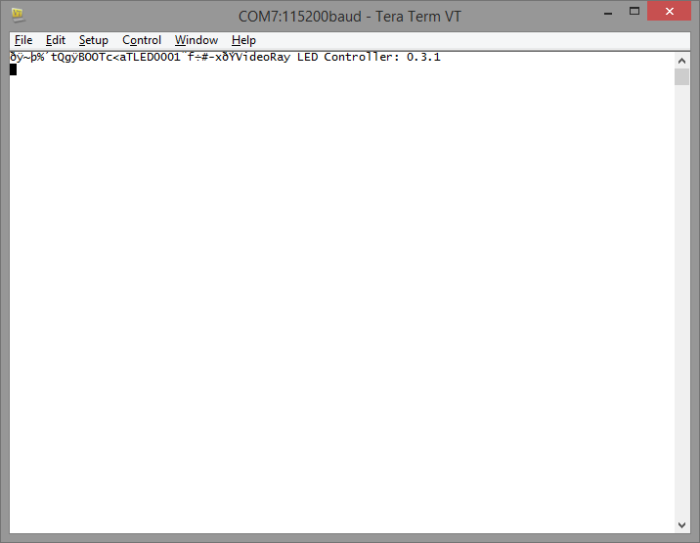

ASCII terminal display showing bootloader message as well as text banner from a module application firmware (LED Controller).